**EXP 9**

**MINI PROJECT**

**Batch: B3 Roll No: 1514117 Experiment No.:9**

**Project Title:**

**ONLINE LAPTOP SHOPPING AND REVIEWS**

**Resources needed:**

PHP, BOOTSTRAP, HTML CSS JAVASCRIPT, JQUERY, AJAX,MYSQL.

**Project Description:**

Laptop reviews is website made to help user get information about various trending laptops and get detailed information about the laptop and can also purchase it by adding items to cart .User needs to login in order to add items to cart .

**________________________________________________________________________**

**Major Functionalities:**

* SHOPPING CART
* SESSION MANAGEMENT

__________________________________________________________________________________

**Minor Functionalities:**

* LOGIN -LOGOUT
* DISPLAY USER DETAILS
* VALIDATION OF ALL FIELDS

__________________________________________________________________________________

**SEO**

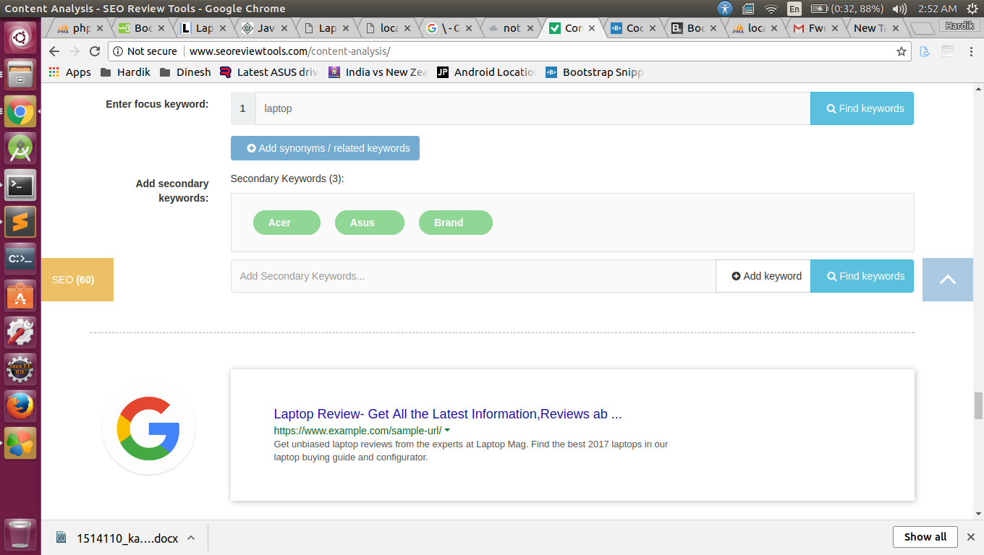

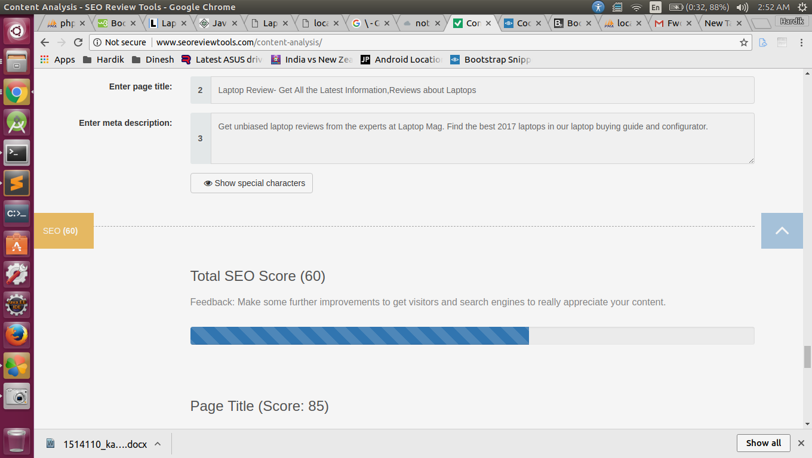

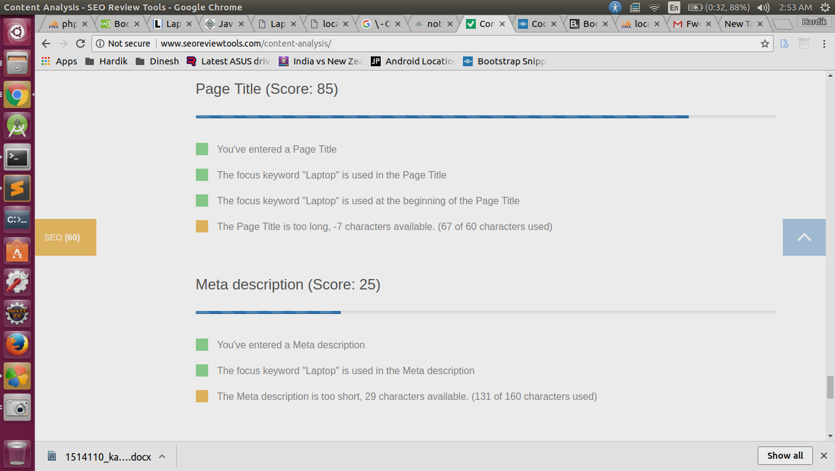

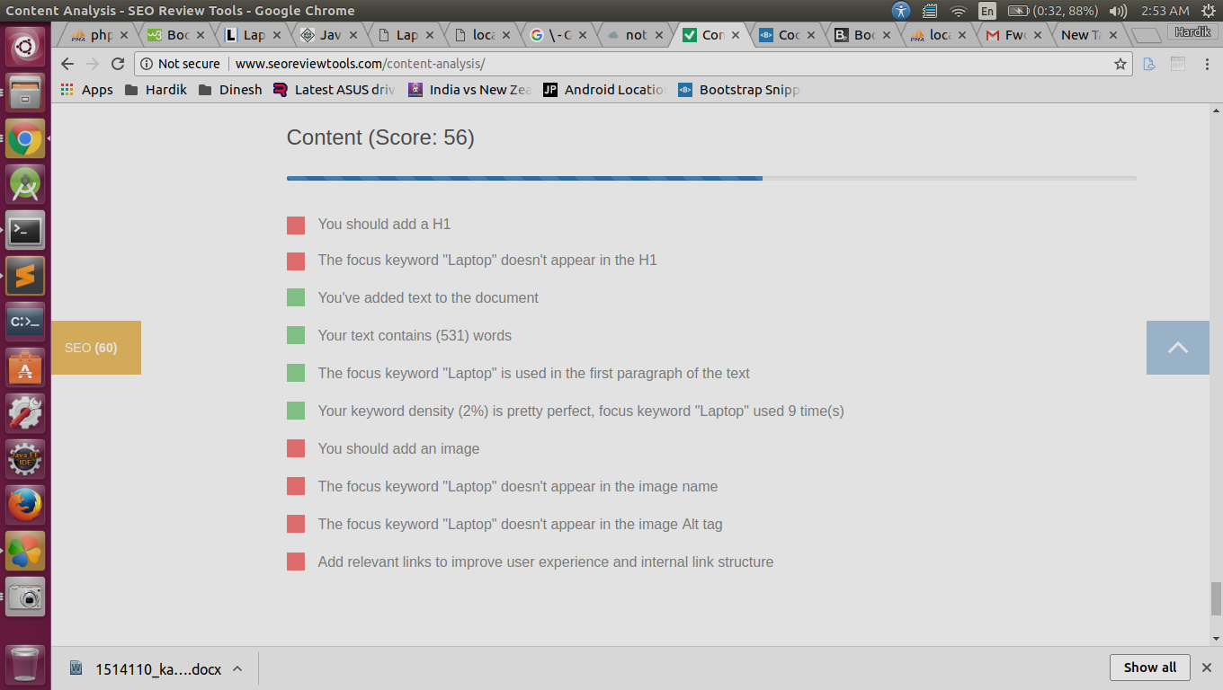

**Conclusion: (Conclusion to be based on the objectives and outcomes achieved)**

Using PHP JAVASCRIPT AJAX MYSQL and BOOTSTRAP backend and front end development was done.Validation and Sending requests to server for processing the response.

**Grade: AA / AB / BB / BC / CC / CD /DD**

**Signature of faculty in-charge with date**

**References:**

[**http://www.studytonight.com/**](http://www.studytonight.com/)

[**https://www.google.co.in/**](https://www.google.co.in/)

[**https://www.w3schools.com/bootstrap/**](https://www.w3schools.com/bootstrap/)